**1. created for webhook on Jenkins**

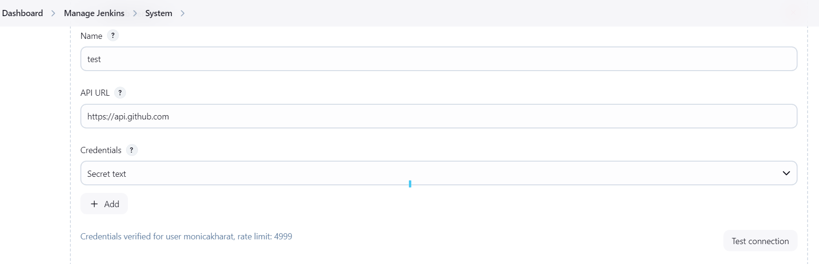

**2.New Job created and credential added:**

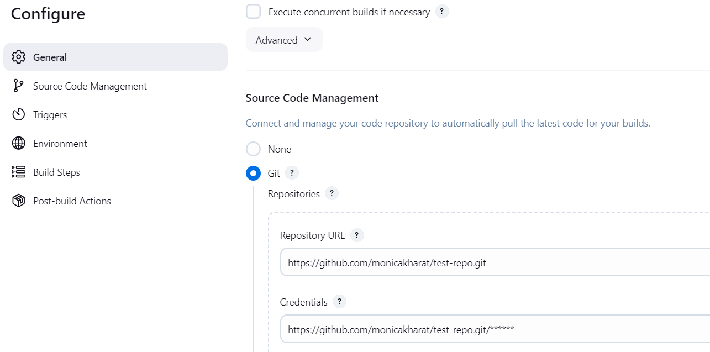

**3.Github repo setting :**

